**Issue:**

Using Rest Implementation Address fields like addressLine1, addressLine2 etc. data is not auto populated in loss event section though using component implementation we are able to save the data.

**Steps:**

The Loss Event Address component is created with following steps:

1. Created class XXClaimsLossEventAddressComponent with following signature:

public class XXClaimsLossEventAddressComponent extends AbstractClaimsComponent implements RulesMetadataProvider {

}

1. Creating the beans.xml for the XXClaimsLossEventAddressComponent  by passing a constructor argument as ClaimsAddressContactDTO .

<bean id="ClaimsLossEventAddressComponent_1_0" parent="LossLocationAddressComponent_1_0"

class="com.XXClaimsLossEventAddressComponent" init-method="initialize">

<constructor-arg index="0" value="com.exigen.ipb.claims.dto.contact.ClaimsAddressContactDTO" type="java.lang.Class"/>

………………………….

</bean>

1. Then we configured the new Loss Event Address component on the product configuration in the admin tab. In the port view of the component section, the lossEventEntity contains LossEvent Component within which Loss Event Address component exists.
2. From there we click connect to create a Loss Event Address component instance. Then we selected required attribute from manage attributes and checked show component label checkbox and saved.
3. Now, the component is visible under Loss Event tab and it also saves data when creating claim through the UI.

Until this point everything is fine but fnol is created via rest service from portal. For that we have followed below steps to save the data

1. Under the mapLossEvent method in Rest class, we added the code to save the details received through payload.

XXLossEventAddress xxcLossEventAddress=new XXLossEventAddress();  
XXLossEventAddress.setAddressLine1(……);//Data from payload  
………………………………………………………………………………………………….  
claimImage.getLossEvent().setXXLossEventAddress(xxLossEventAddress);

1. In the XXClaimsRepositoryImpl , we have added following code to save the data and also added one method to retrieve loss event address details and setting in claim image.

public class XXClaimsRepositoryImpl extends ClaimsRepositoryImpl {

…………………………………………………………………………..

public ClaimImage createClaim(ClaimImage claimImage) {

ClaimsComponentCreationContext lossEventContext = new ClaimsComponentCreationContext(entityConfiguration, claimsEntity, precClaimImage.getLossEvent(), *PORT_LOSS_EVENT_ENTITY*);  
instantiateLossEvent(claimsEntity, componentInstances, lossEventContext, precClaimImage.getLossEvent());

}

protected XXLossEventAddress retrieveLossEventAddress(XXClaimsLossEventEntity lossEventEntity) {  
 List<ClaimsAddressContactDTO> claimsAddressContactDTOList= lossEventEntity.getAddresses();  
 com.exigen.ipb.base.datatypes.Address addr=claimsAddressContactDTOList.get(0).getAddressContact().getAddress();  
 XXLossEventAddress xxLossEventAddress=new XXLossEventAddress();  
 xxLossEventAddress.setAddressLine1(addr.getAddressLine1());  
 …………………………………………………………….

………………………………………………………………….  
 return xxLossEventAddress;  
 }

}

1. When we try to pass the Address details through payload while creating a new claim using rest service, the address details are getting saved in ClaimsAddressContactEntity table and Claim is also created. But the address details does not show up in UI.

Actually we have developed the Loss Event Address component similar to what you said and it displays on the UI as expected (Refer to below two screenshots)

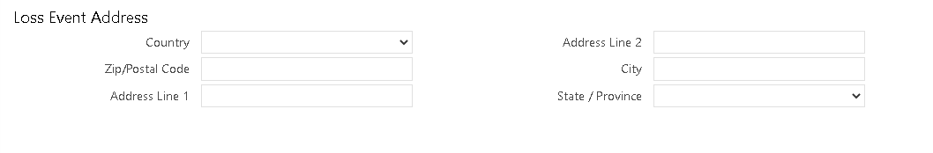

After saving:

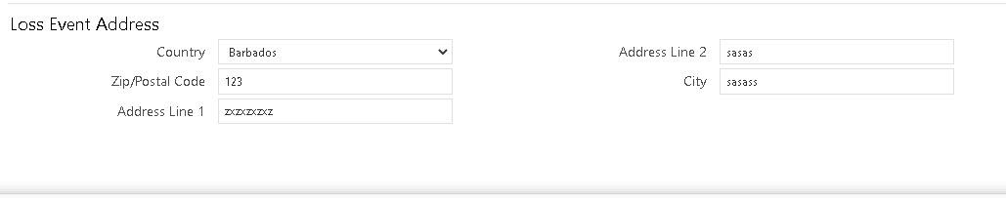

But issue is when we save the loss event contact data using payload from REST Api , I see 3 entries in CLAIMSADDRESSCONTACTENTITY table (like below screenshot) and UI does not show any loss event address data

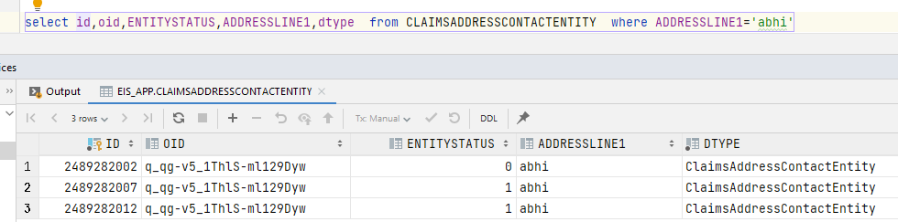

For your reference ,the payload looks something like below. incidentAddress is the field we are trying to save:

{

"meta": {},

"claim": {

"fnolSubmissionId": "d3cedadf-b2b7-46f9-8cbb-f64e0a474ra3",

"lossId": "d3cedadf-b2b7-46f9-8cbb-764e0a471483-XX",

"productCode": "XXXX",

…………………………………………………………………………………….

"loss": {

"lossDt": "2019-12-18T10:31:18Z",

"reportedDt": "2019-12-18T10:31:18Z",

"incidentAddress": {

"addressLine1": "1010 Mass Ave",

"city": "Boston",

"countryCd": "US",

"postalCode": "02119",

"stateProvCd": "MA"

}

}

}

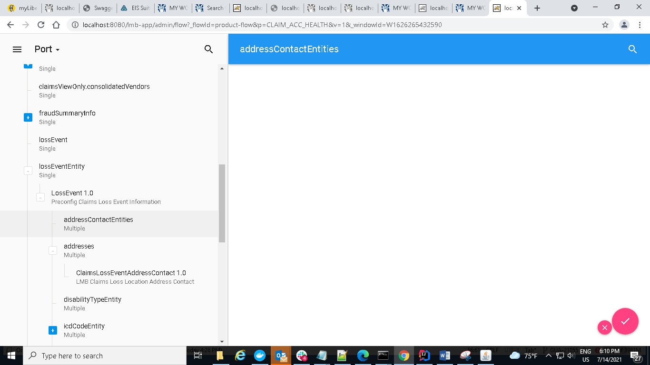

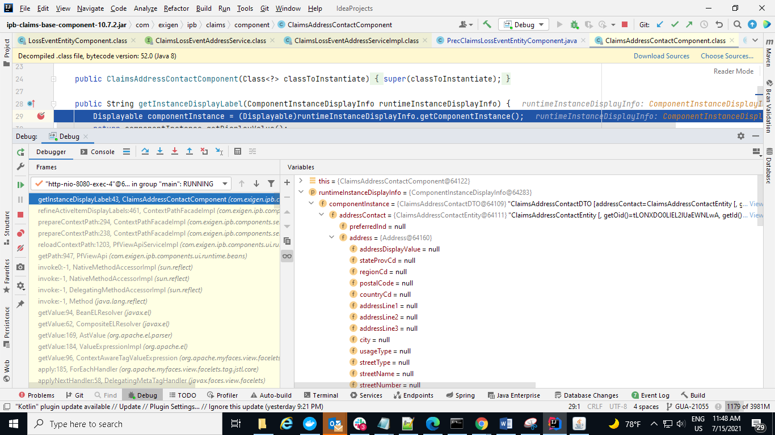

Reporting Party:

